Ghatanothoa
(for duet)

part of the Great Old Ones cycle using the
Seesar Lovecraftian Futurist Composition Card System

Published by Batrachian Ancestor. General copyright 2026 William Klugh Connor III. Free to perform and record with the understanding any performance and documentation of a performance will be shared with the author of the card system. Contact Will Connor via will.connor@seesarmusic.com
For more pieces or a free copy of the Seesar Lovecraftian Futurist Composition Card System, visit SeesarMusic.com
Ghatanothoa (for duet)
Instructions:
Play the cards in the order and length in which they are presented here:
Time (length to play card) | Voice 01 | Voice 02
Min 0-1 | 023-B | Rest
Min 1-2 | 091-B | 091-B
Min 2-3 | 142-B | 149-A
Min 3-4 | 051-A | Con’t
Min 4-5 | 108-B | 105-B
Min 5-6 | 105-B | Con’t
Min 6-7  or freely, as desired | C019-B | C019-B

“Con’t” indicates continue playing the card from the previous time block. For example, Voice 02 will play card 149-A from the 2:00 min mark to the 4:00 min mark.
Approximate total time – 7 mins
Suggested sound family foci noted on individual cards.
Suggested support reading includes Out of the Aeons (Lovecraft) with a focus ship captain. Additional reading includes The Thing in the Pit (Carter) and The Return of Lliogor (Wilson).

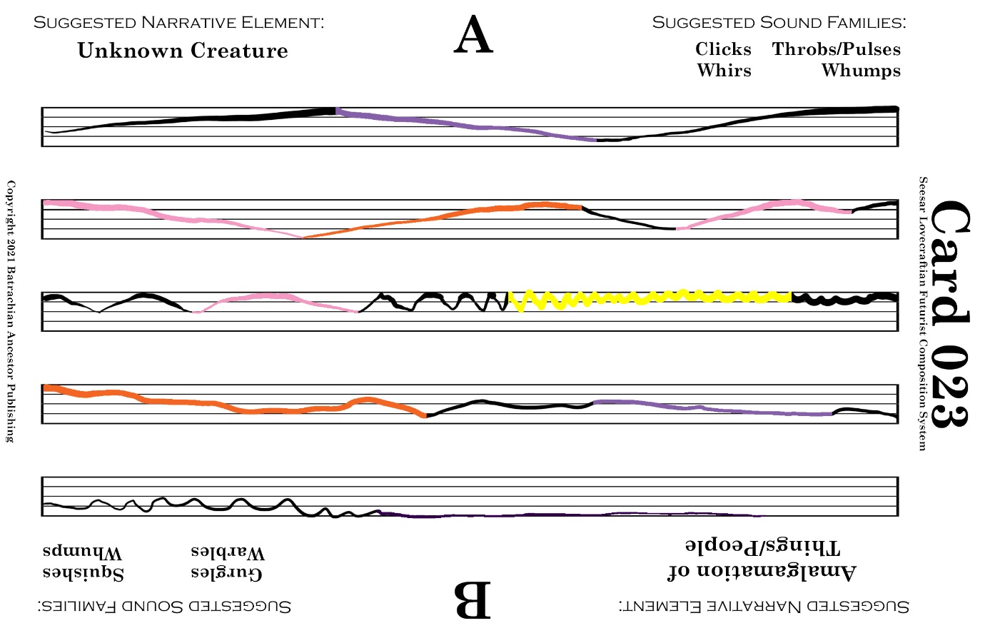

Ghatanothoa Voice 01 Min 0-1

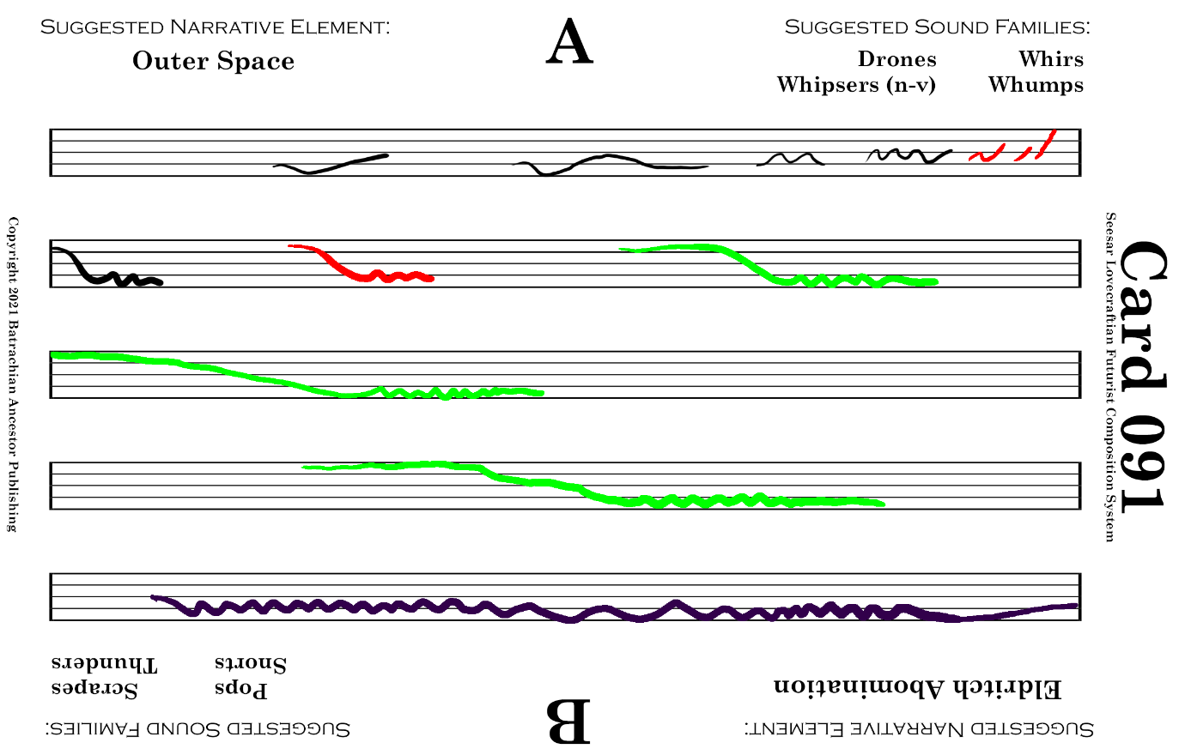

Ghatanothoa Voice 01 Min 1-2

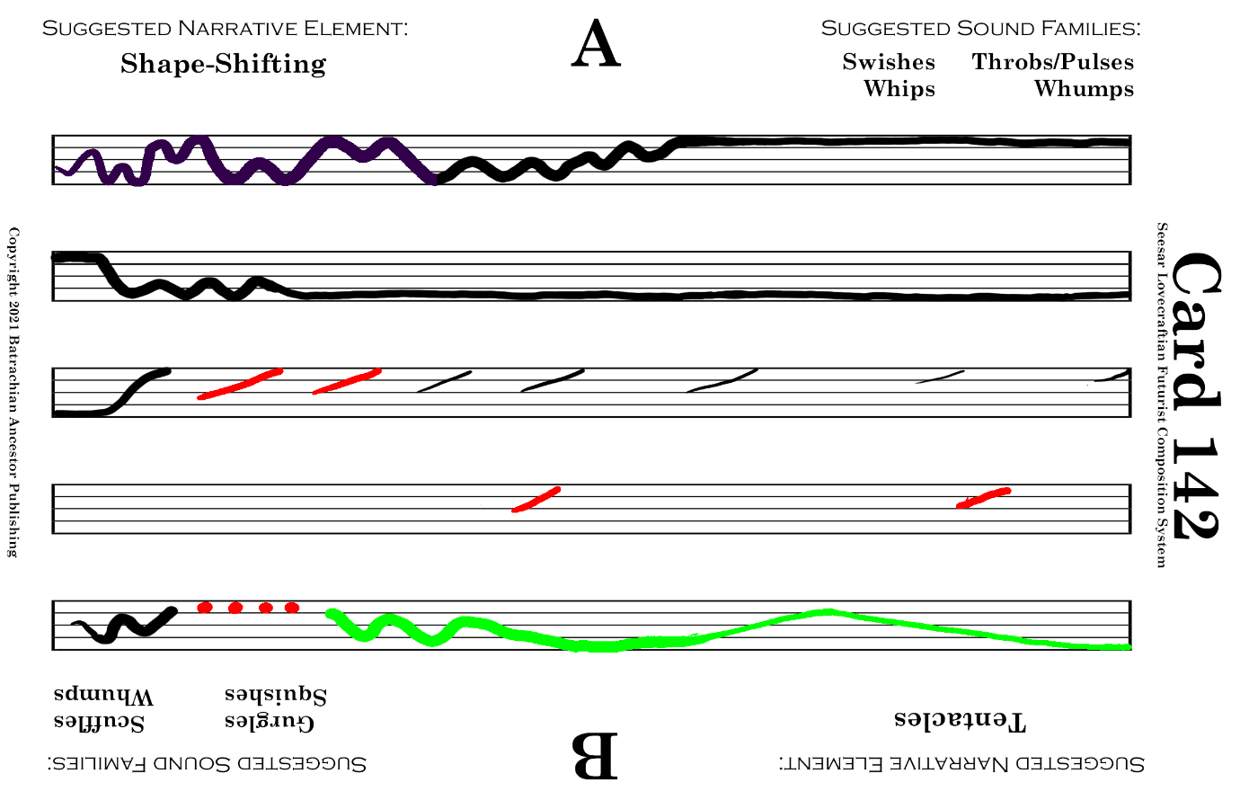

Ghatanothoa Voice 01 Min 2-3
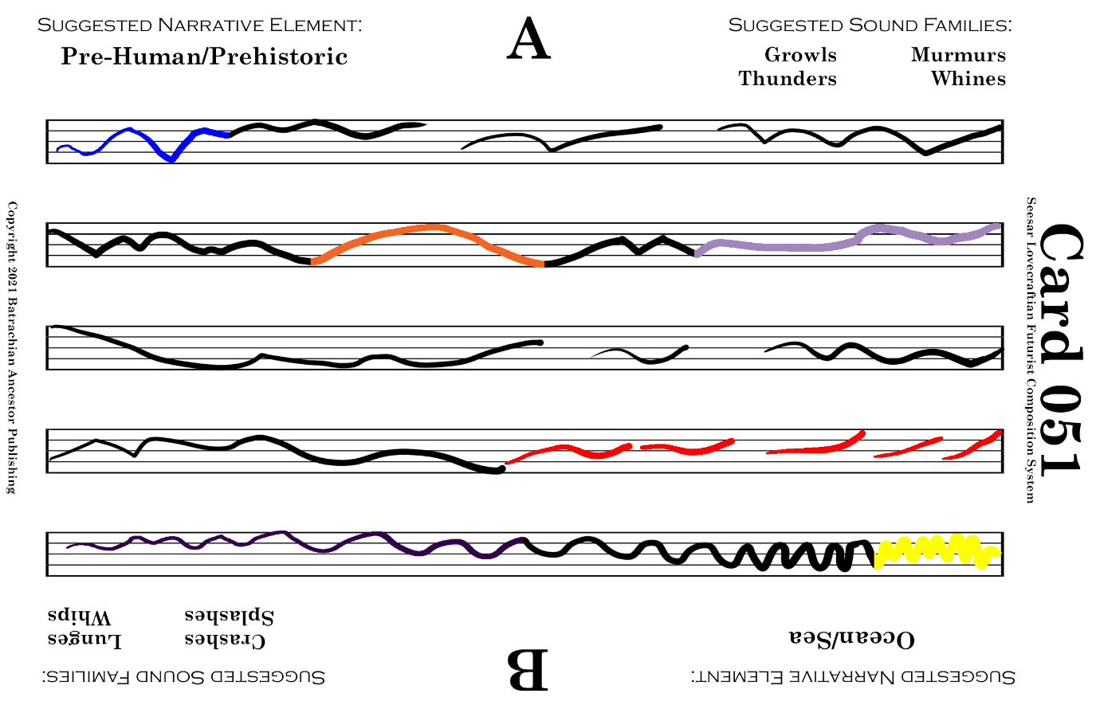

Ghatanothoa Voice 01 Min 3-4

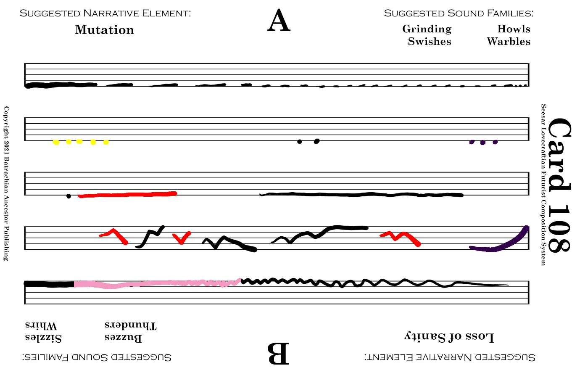

Ghatanothoa Voice 01 Min 4-5

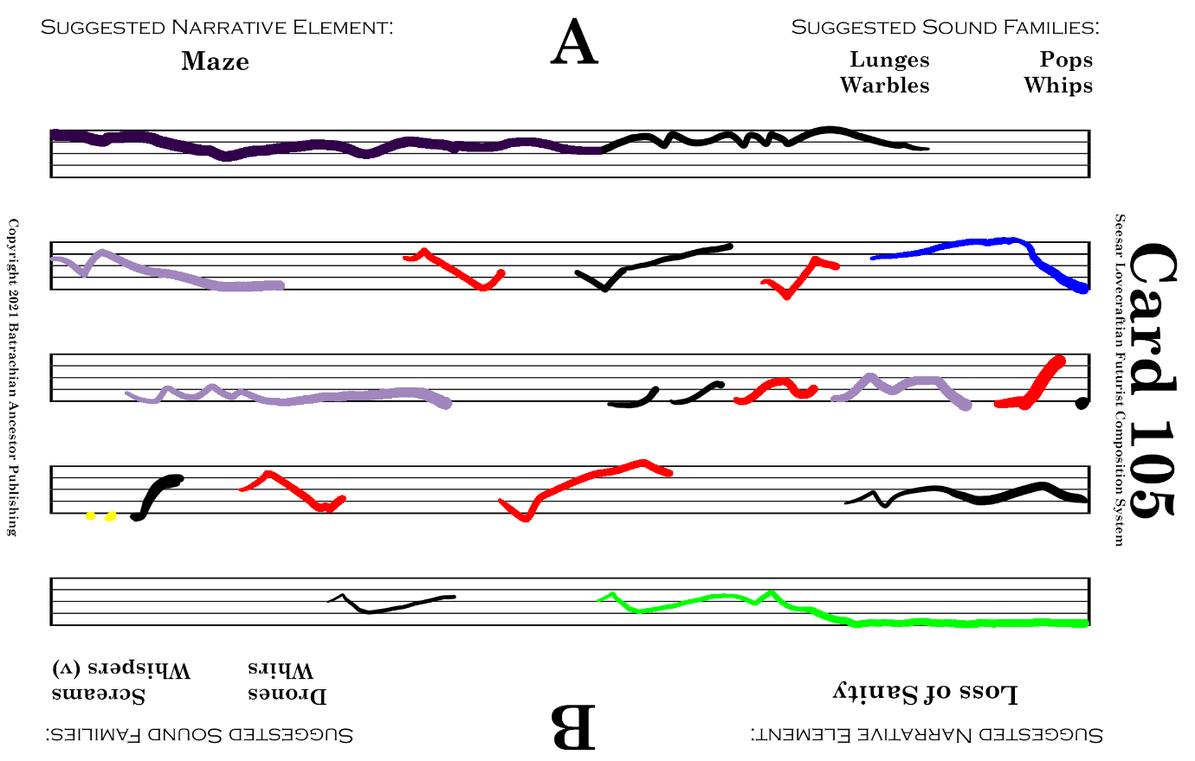

Ghatanothoa Voice 01 Min 5-6

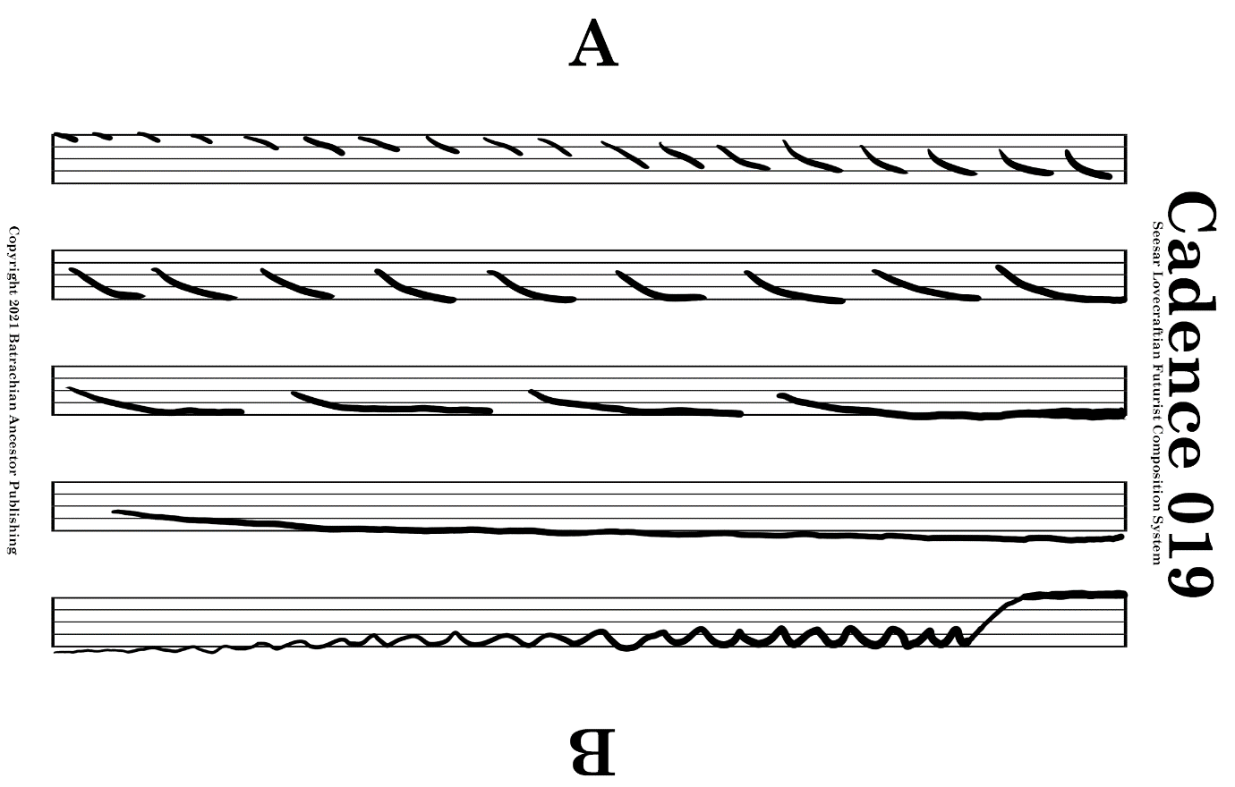

Ghatanothoa Voice 01 Min 6-7

1 Min.
Rest

Ghatanothoa Voice 02 Min 0-1

Ghatanothoa Voice 02 Mins 1-2

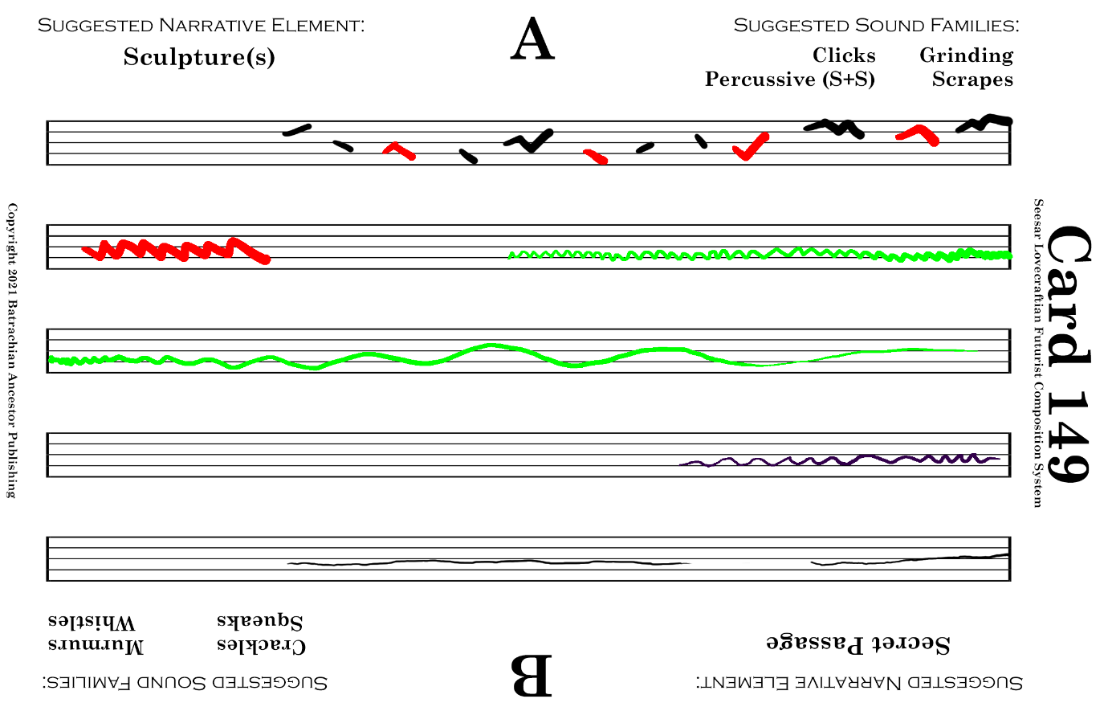

Ghatanothoa Voice 02 Mins 2-4

Ghatanothoa Voice 02 Min 4-6

Ghatanothoa Voice 02 Min 6-7

