Gobogeg aka the Moon Ladder
(for solo artist)

part of the Great Old Ones cycle using the
Seesar Lovecraftian Futurist Composition Card System

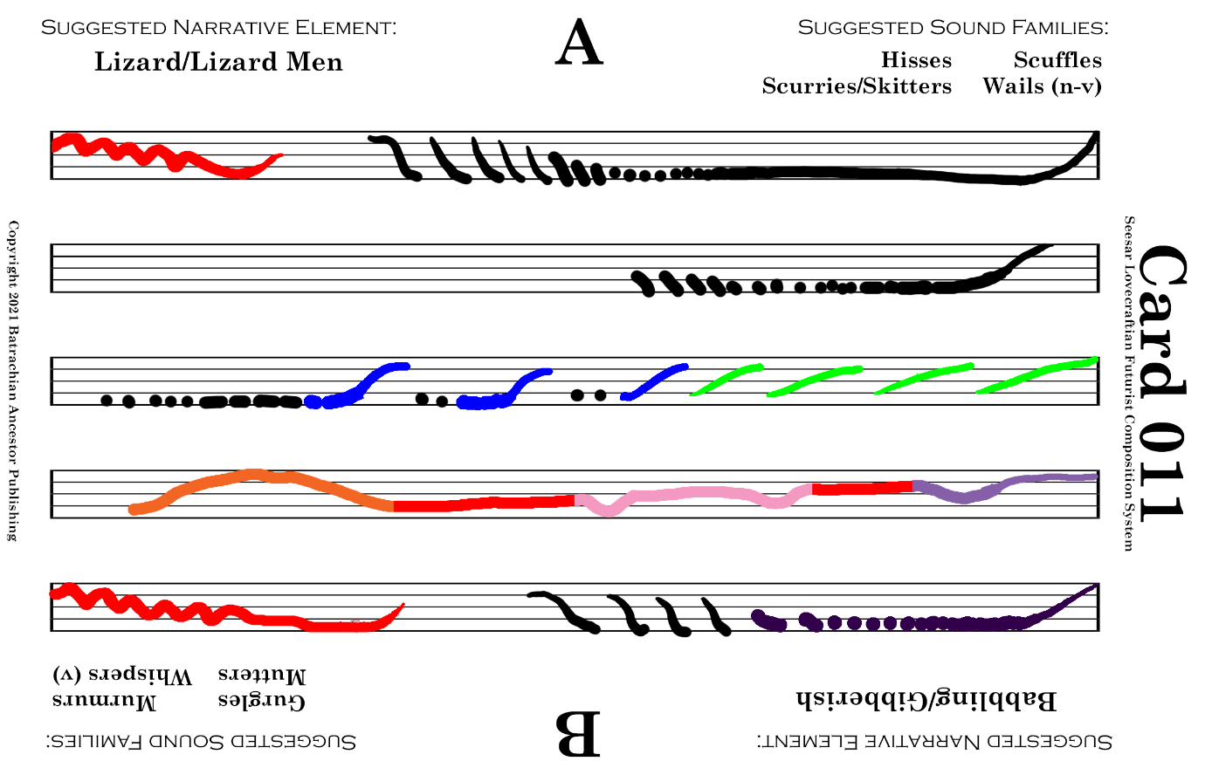

Play this card for ~2 mins. Any suggested sound family is acceptable.
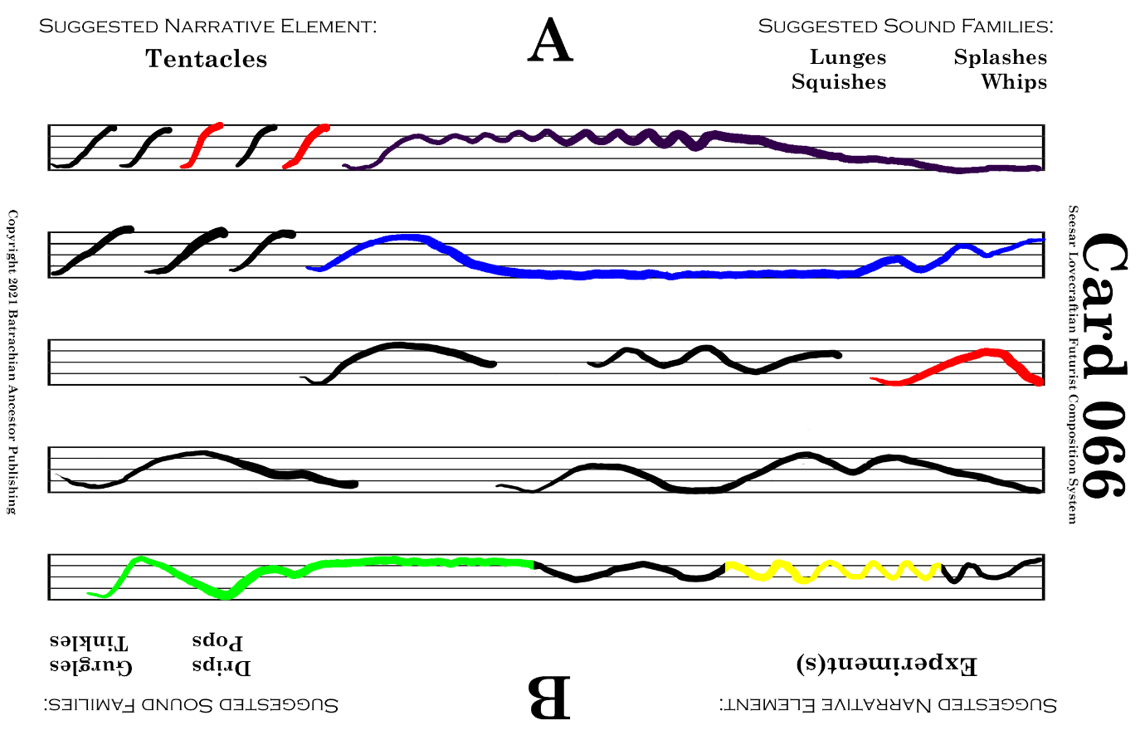

Play this card for ~2 mins. Focus on Squishes and Lunges for the suggested sound families.
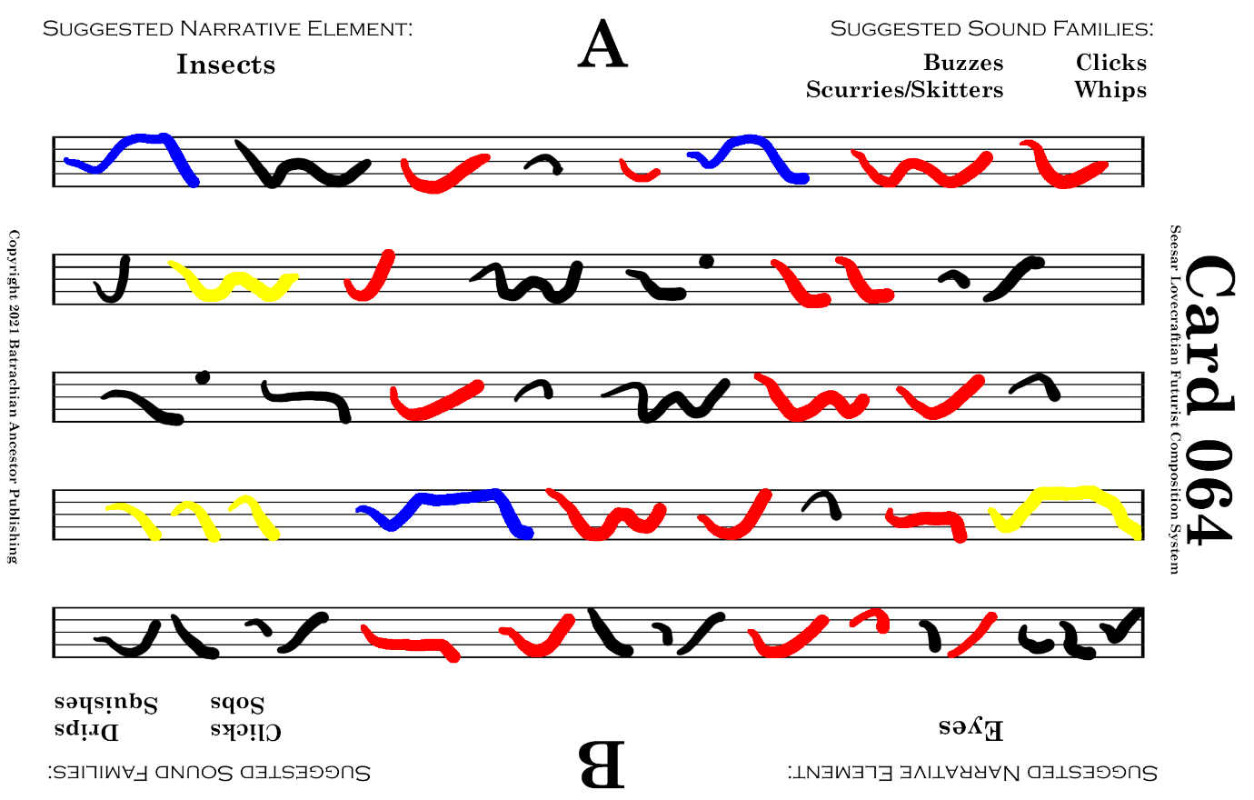

Play this card for ~1 min. Focus on Scurries and Skitters for the suggested sound family.
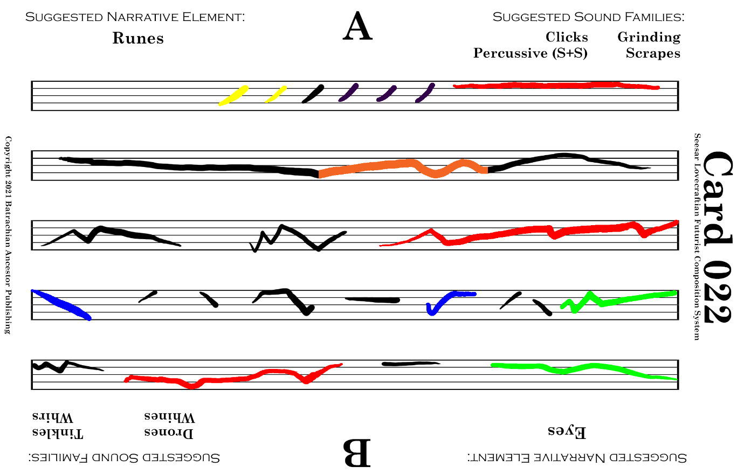

Play this card for ~2 mins. Any suggested sound family is acceptable.
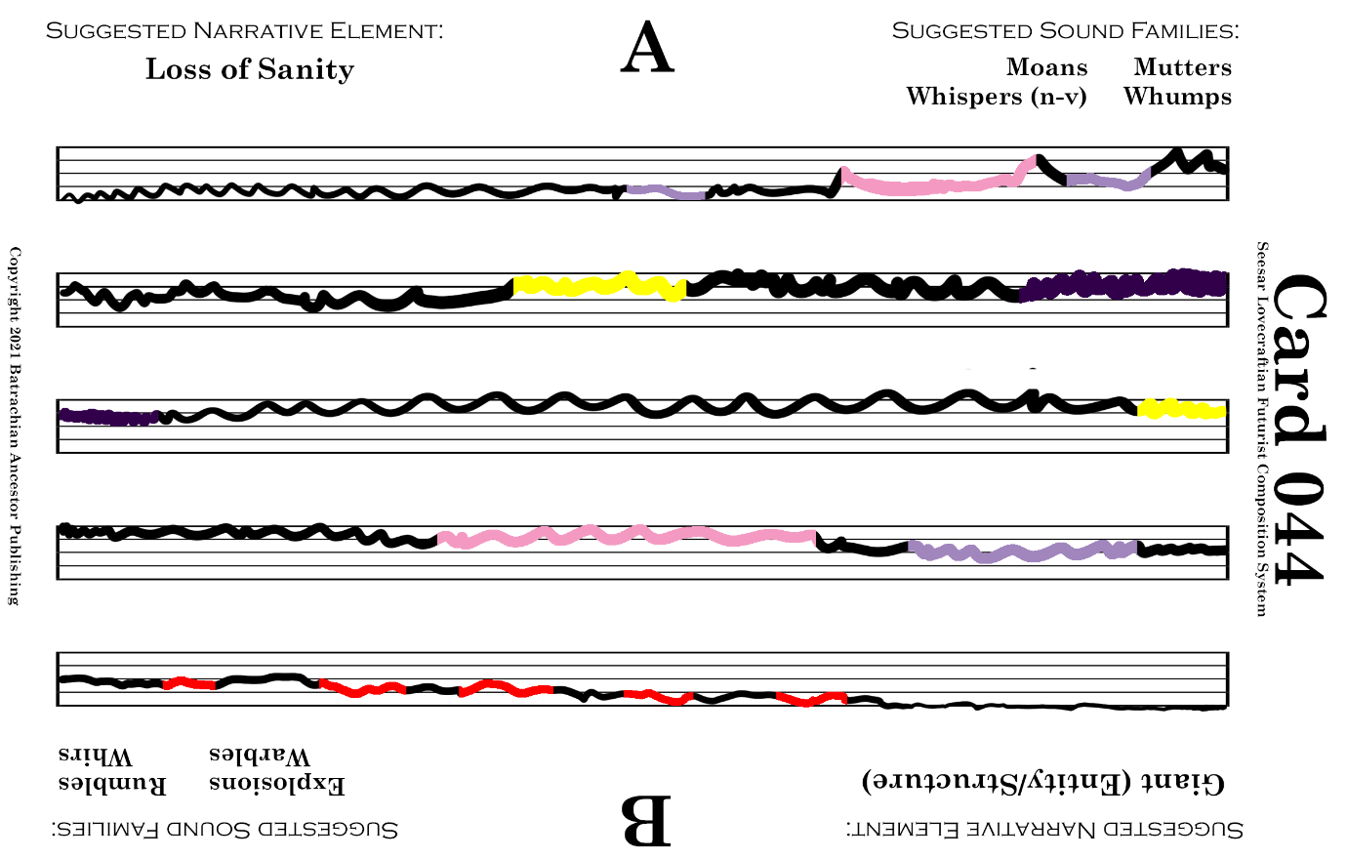

Play this card for ~1 min. Any suggested sound family is acceptable, including mixing sounds.
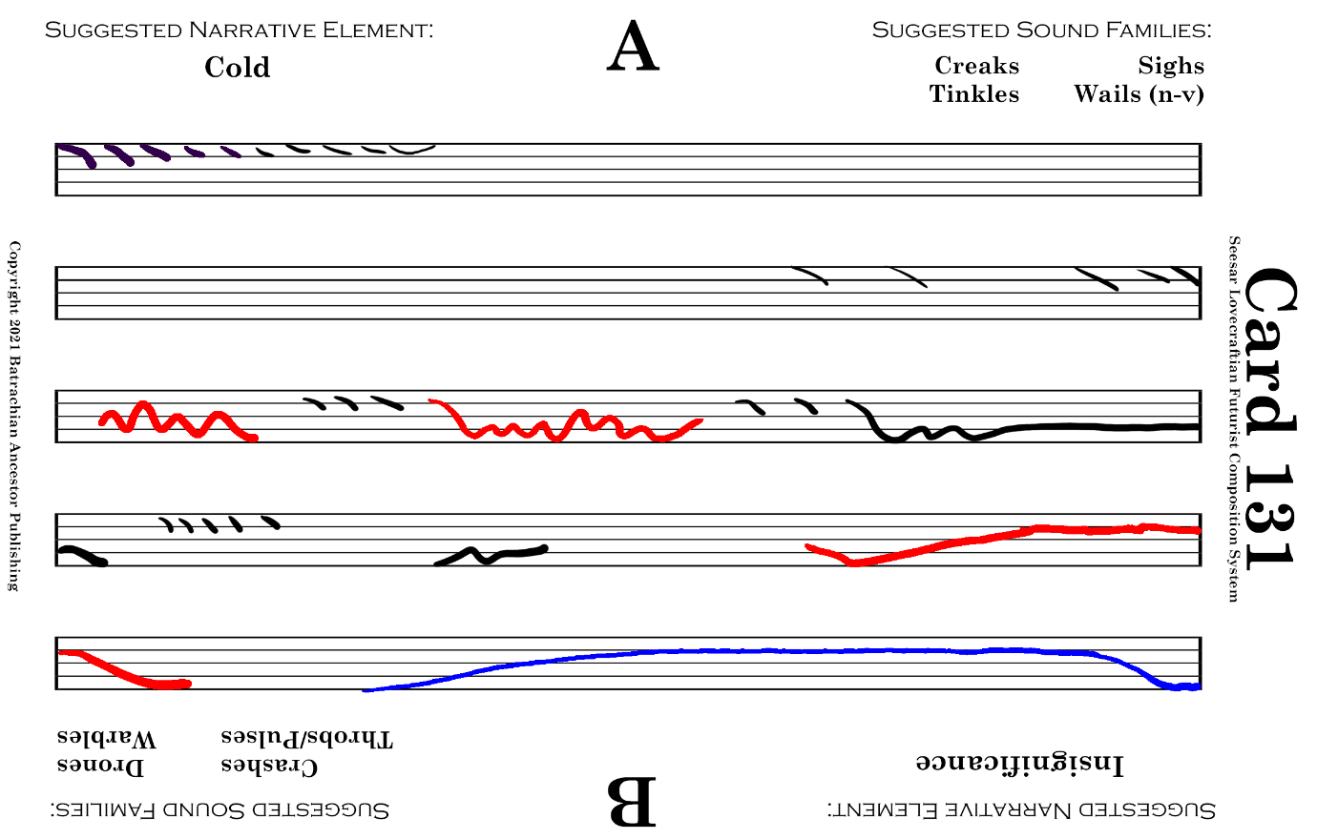

Play this card for ~1 min. Any suggested sound family is acceptable, including mixing sounds.
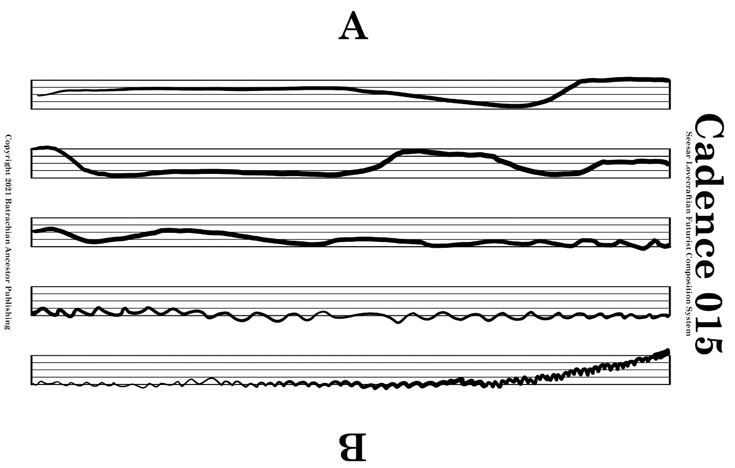

Play this card as long as desired with a focus on the cadence ending on the highest note.
Gobogeg aka the Moon Ladder (for solo artist)
Instructions:
Play the cards in the order and length in which they are presented here:
011-B (~2 mins)
066-A (~2 mins)
064-B (~1 min)
022-B (~2 mins)
044-B (~1 min)
131-B (~1 min)
C015-A (as desired)
Approximate total time – 10 mins
Suggested sound family foci noted on individual cards.
Suggested support reading includes At the Mountains of Madness with a focus on Danforth and his condition towards the end of the story. Furthermore, performers can draw from the knowledge that Gobogeg is a destroyer of worlds (when summoned unexpectedly) and takes the form of a giant spine or tentacle with a singular eye a top it’s massive wavering mass.

Published by Batrachian Ancestor. General copyright 2026 William Klugh Connor III. Free to perform and record with the understanding any performance and documentation of a performance will be shared with the author of the card system. Contact Will Connor via will.connor@seesarmusic.com
For more pieces or a free copy of the Seesar Lovecraftian Futurist Composition Card System, visit SeesarMusic.com

