Rhan-Tegoth
(for duet)

part of the Great Old Ones cycle using the
Seesar Lovecraftian Futurist Composition Card System

Published by Batrachian Ancestor. General copyright 2026 William Klugh Connor III. Free to perform and record with the understanding any performance and documentation of a performance will be shared with the author of the card system. Contact Will Connor via will.connor@seesarmusic.com
For more pieces or a free copy of the Seesar Lovecraftian Futurist Composition Card System, visit SeesarMusic.com
Rhan-Tegoth (for duet)
Instructions:
This composition can be played one of three lengths and various iterations of those three lengths. It should be agreed upon by the players/conductor which length will be performed prior to playing the piece.
The short version is approximately 9 mins long and omits the optional cards 138-B and 146-B.
The medium-length version is approximately 10 minutes long and includes one minute of either card 138-B and 146-B to be played by each player in any of these predetermined configurations: Voice 01 plays 138-B and Voice 02 plays 146-B; Voice 01 plays 146-B and Voice 02 plays 138-B; both Voice01 and Voice 02 play 138-B (and 146-B is omitted); or both Voice 01 and Voice 02 play 146-B (and 138-B is omitted). The optional cards should be played between the 6-minute mark and the 7-minute mark.

The longest-length version is approximately 11 minutes long and includes two minutes of any combination of 138-B and 146-B played by both Voice 01 and Voice 02. The optional cards should be played between 6-minute mark and the 8-minute mark.
The piece can also be played in one of two modes (semi-reversed modes). Players should decide prior to a performance to play the “Awakening” mode or the “Slumbering” mode. Play the cards in the order and length outlined for the selected mode.

To play Rhan-Tegoth in “Awakening” mode, play the cards in the order and length in which they are presented here:
Time (length to  play card) | Voice 01 | Voice 02
Min 0-1 | 075-A | Rest
Min 1-2 | Con’t | 075-A
Min 2-3 | Con’t | Con’t
Min 3-4 | 141-A | 039-A
Min 4-5 | 064-A | Con’t
Min 5-6 | Con’t | 079-A
Min 6-7 | (optional  card 01) | (optional  card 01)
Min 7-8 | (optional  card 02) | (optional  card 02)
Min 8-9 | 141-A | 079-A
Min 9-10 | 064-A | Con’t
Min 10-11 | 141-A | 017-B
Min 11-12  or freely, as desired | C010-B | C010-B

To play Rhan-Tegoth in “Slumbering” mode, play the cards in the order and length in which they are presented here:
Time (length to  play card) | Voice 01 | Voice 02
Min 0-1 | 064-A | Rest
Min 1-2 | Con’t | 017-B
Min 2-3 | Con’t | Con’t
Min 3-4 | 141-A | 079-A
Min 4-5 | 064-A | Con’t
Min 5-6 | 141-A | Con’t
Min 6-7 | (optional  card 01) | (optional  card 01)
Min 7-8 | (optional  card 02) | (optional  card 02)
Min 8-9 | 141-A | 039-A
Min 9-10 | 075-A | Con’t
Min 10-11 | Con’t | 075-A
Min 11-12  or freely, as desired | C010-A | C010-A

“Con’t” indicates continue playing the card from the previous time block. For example, in “Slumbering” mode playing the long-length version, Voice 01 will play card 075-A from the 9:00 min mark to the 11:00 min mark.
Approximate total time – 10-12 mins (depending on the target length selected).
Suggested sound family foci noted on individual cards.
Suggested support reading includes Horror in the Museum (Lovecraft and Heald) and Lurker at the Threshold (Derleth). Additional reading includes Acolyte of the Flame (Carter), Perchance to Dream (Carter), Wilbur Whateley Waiting (Price), and The Return of Rhan-Tegoth (Cornford).

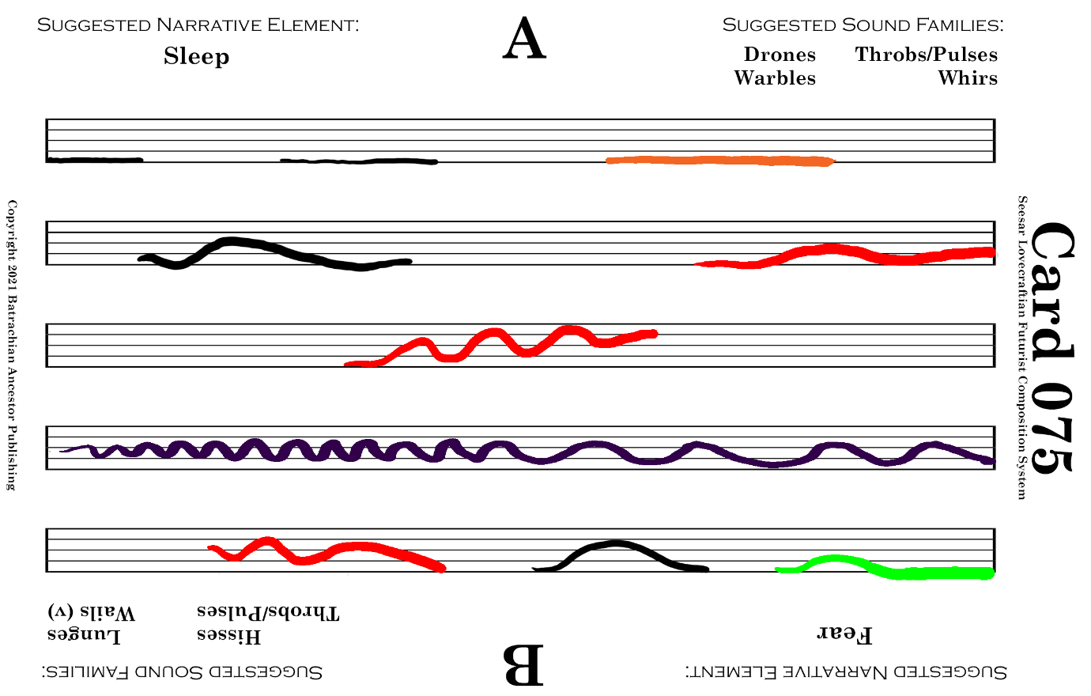

Rhan-Tegoth Voice 01 Min 0-3 (Awakening mode)

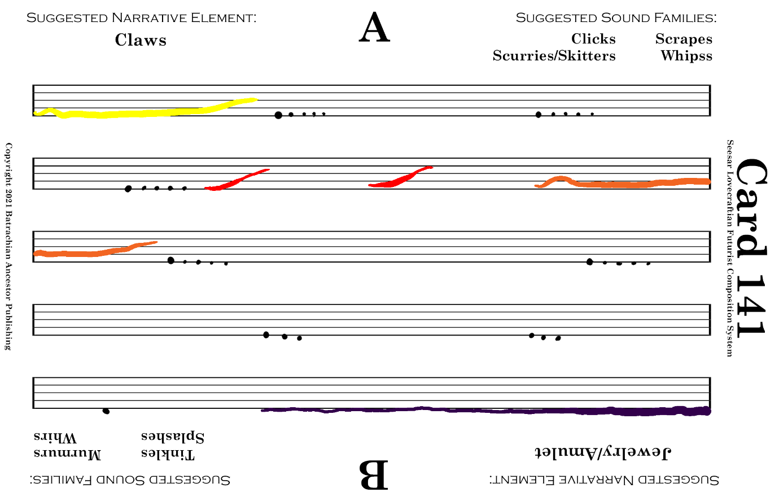

Rhan-Tegoth Voice 01 Min 3-4 (Awakening mode)
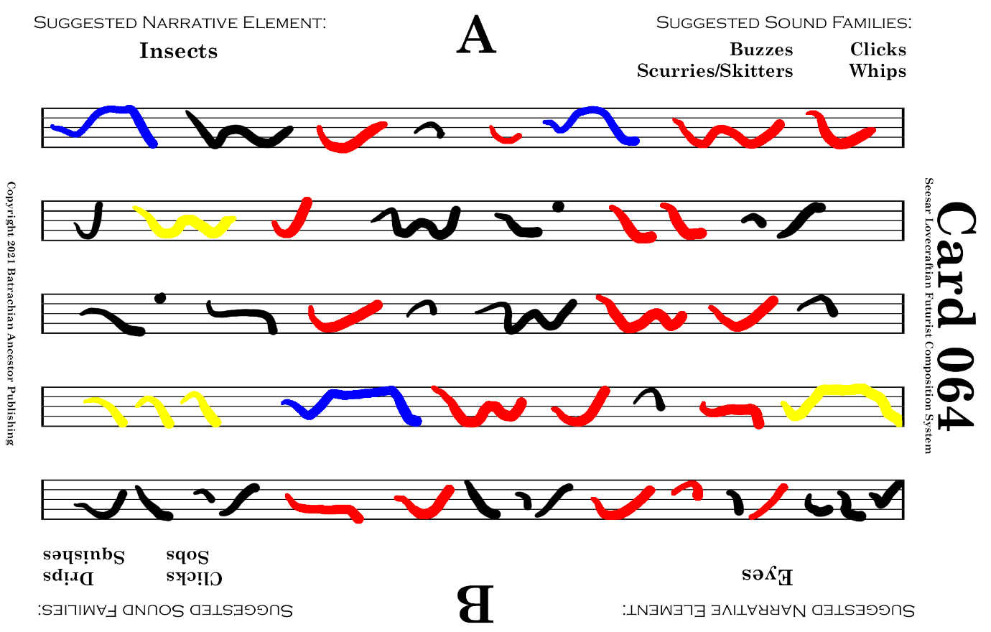

Rhan-Tegoth Voice 01 Min 4-6 (Awakening mode)
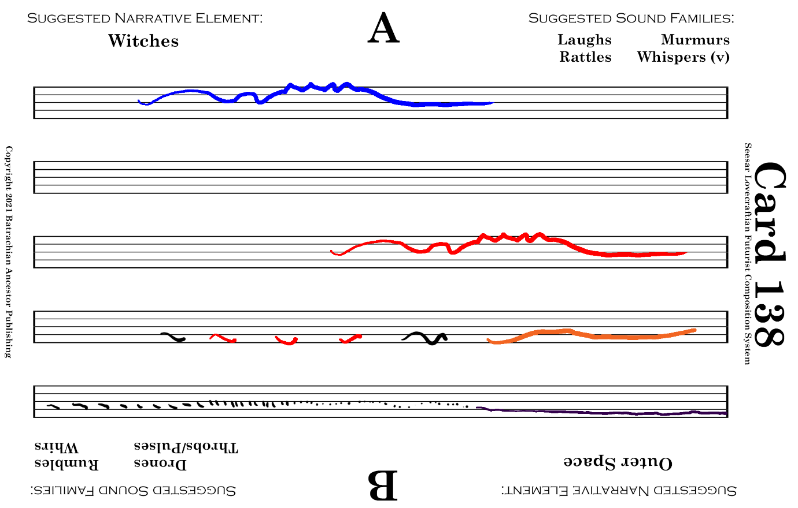

Rhan-Tegoth Voice 01 Min 6-7-8 (Awakening mode) [Optional – adjust times accordingly]

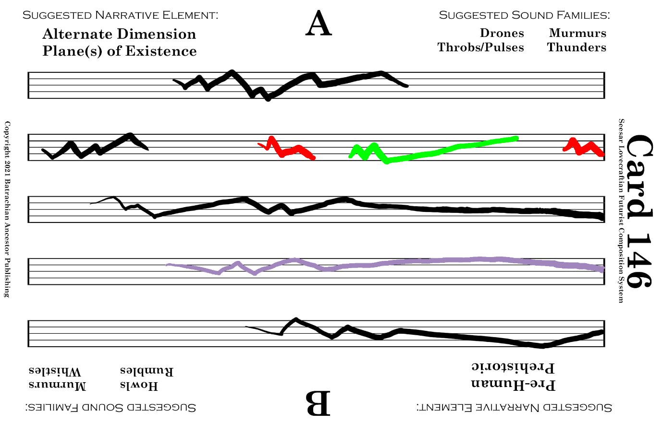

Rhan-Tegoth Voice 01 Min 6-7-8 (Awakening mode) [Optional – adjust times accordingly]

Rhan-Tegoth Voice 01 Min 8-9 (Awakening mode)

Rhan-Tegoth Voice 01 Min 9-10 (Awakening mode)

Rhan-Tegoth Voice 01 Min 10-11 (Awakening mode)
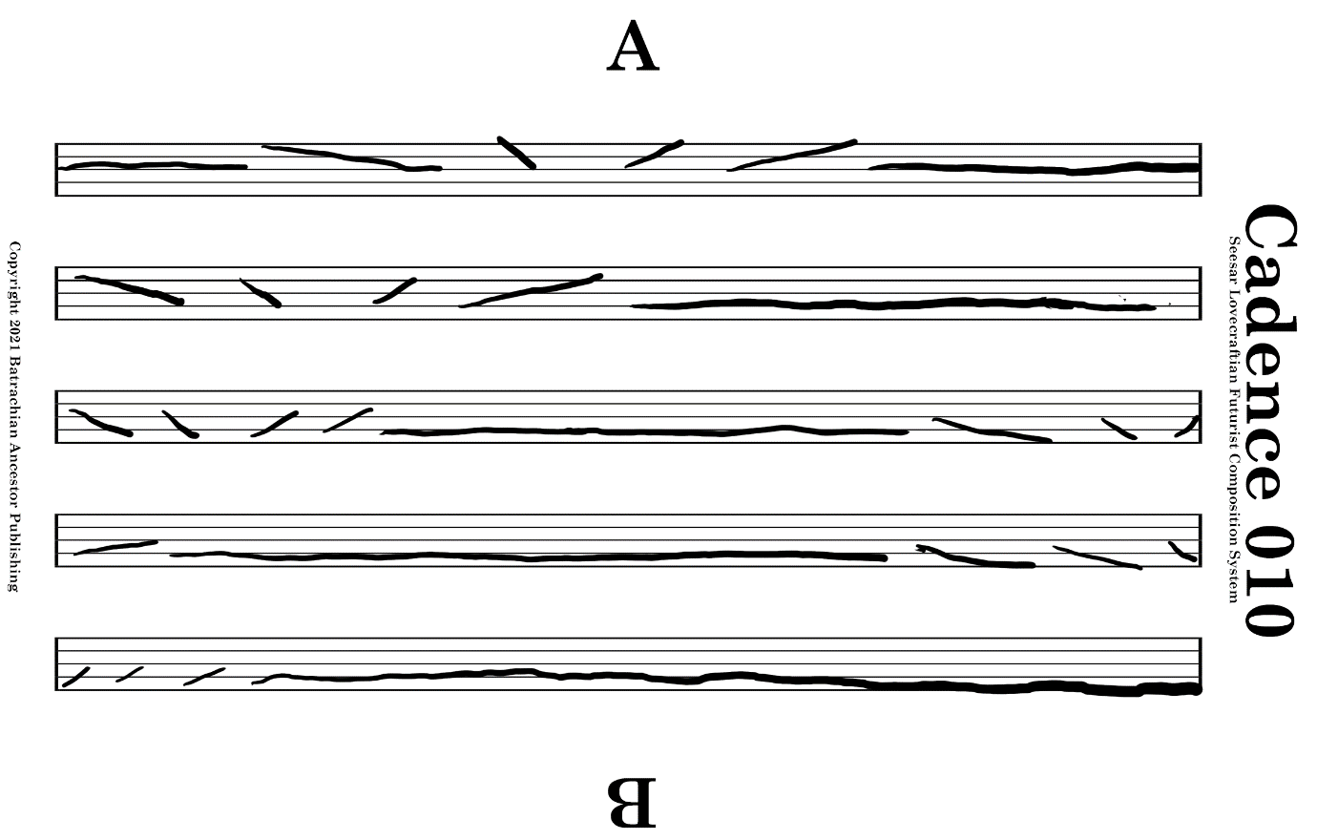

Rhan-Tegoth Voice 01 Min 11-12 (Awakening mode)

1 Min.
Rest

Rhan-Tegoth Voice 02 Min 0-1 (Awakening mode)

Rhan-Tegoth Voice 02 Min 1-3 (Awakening mode)
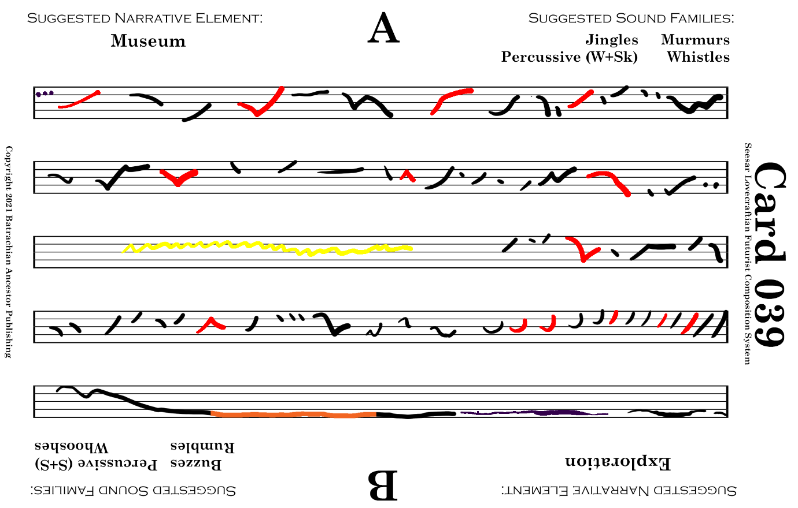

Rhan-Tegoth Voice 02 Min 3-5 (Awakening mode)
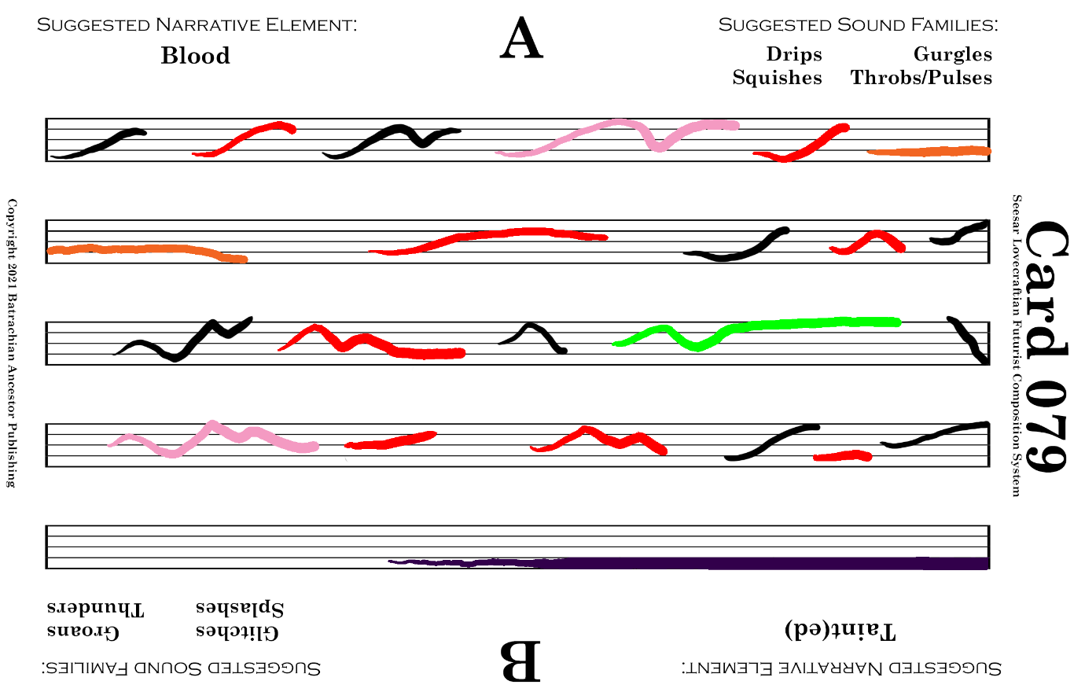

Rhan-Tegoth Voice 02 Min 5-6 (Awakening mode)

Rhan-Tegoth Voice 02 Min 6-7-8 (Awakening mode) [Optional – adjust times accordingly]

Rhan-Tegoth Voice 02 Min 6-7-8 (Awakening mode) [Optional – adjust times accordingly]

Rhan-Tegoth Voice 02 Min 8-10 (Awakening mode)
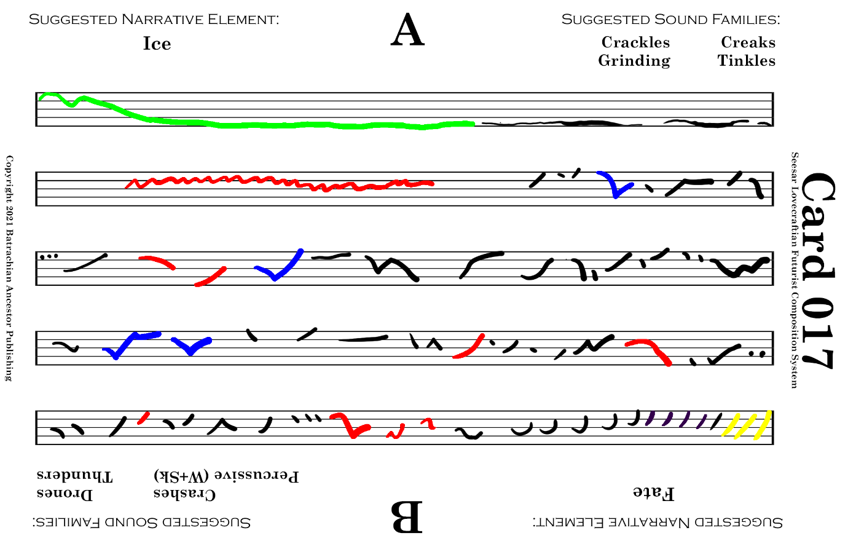

Rhan-Tegoth Voice 02 Min 10-11 (Awakening mode)

Rhan-Tegoth Voice 02 Min 11-12 (Awakening mode)

Rhan-Tegoth Voice 01 Min 0-3 (Slumbering mode)

Rhan-Tegoth Voice 01 Min 3-4 (Slumbering mode)

Rhan-Tegoth Voice 01 Min 4-6 (Slumbering mode)

Rhan-Tegoth Voice 01 Min 6-7-8 (Slumbering mode) [Optional – adjust times accordingly]

Rhan-Tegoth Voice 01 Min 6-7-8 (Slumbering mode) [Optional – adjust times accordingly]

Rhan-Tegoth Voice 01 Min 8-9 (Slumbering mode)

Rhan-Tegoth Voice 01 Min 9-11 (Slumbering mode)

Rhan-Tegoth Voice 01 Min 11-12 (Slumbering mode)

1 Min.
Rest

Rhan-Tegoth Voice 02 Min 0-1 (Slumbering mode)

Rhan-Tegoth Voice 02 Min 1-3 (Slumbering mode)

Rhan-Tegoth Voice 02 Min 3-6 (Slumbering mode)

Rhan-Tegoth Voice 02 Min 6-7-8 (Slumbering mode) [Optional – adjust times accordingly]

Rhan-Tegoth Voice 02 Min 6-7-8 (Slumbering mode) [Optional – adjust times accordingly]

Rhan-Tegoth Voice 02 Min 8-10 (Slumbering mode)

Rhan-Tegoth Voice 02 Min 10-11 (Slumbering mode)

Rhan-Tegoth Voice 02 Min 11-12 (Slumbering mode)

